**Accounts of ‘Not for Profit’ Concerns & Single Entry System – Set - 2**

**Q.1. Objective type questions:**

**(A) Fill in the blanks with appropriate alternative given in the brackets. [5]**

1. nominal account 2. capital 3. Income & Expenditure a/c

4. an asset 5. Subscription 6. Opening Statement of Affair.

7. Statement of affairs 8. 45,000 9. deducted

10. 41,000

**(B) Write a word or a phrase which can substitute each of the following statements [5]**

1. Endowment fund life 2. Capital receipts

3. Subscription 4. Receipt & payment a/c

5. Balance sheet 6. Double entry system

7. Single entry system 8. Double entry system

9. Capital 10. Sole Trading Concern & partnership firm

**(C) State with reasons whether the following statements are true or false [5]**

1. False 2. False 3. False 4. True 5. True

6. False 7. False 8. True 9. False 10. True

**Q.2.**

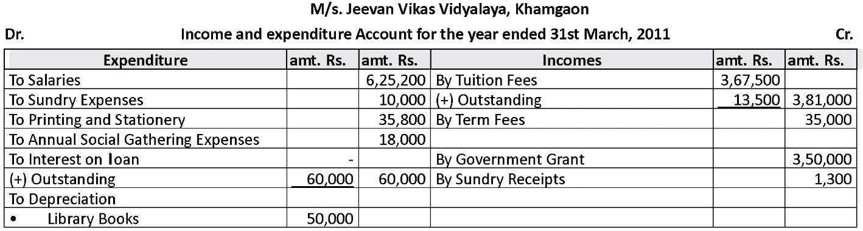

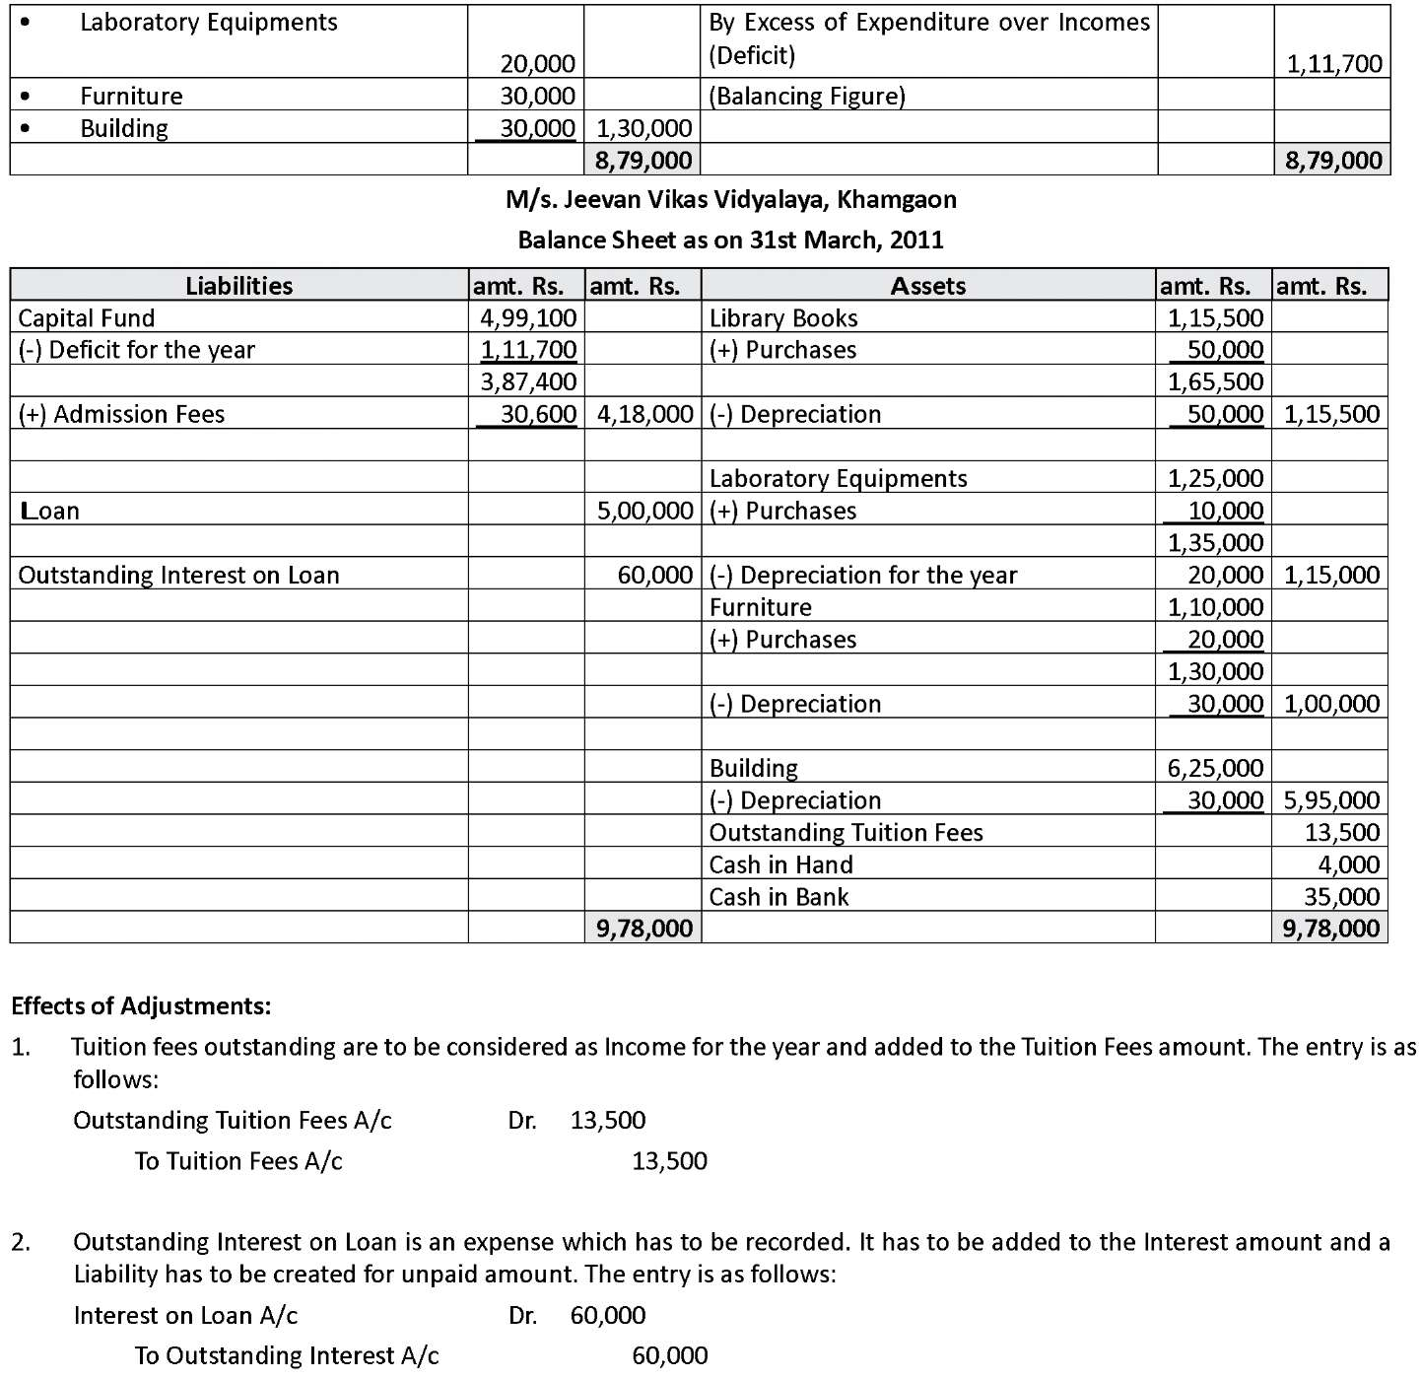



**Q.3.**



